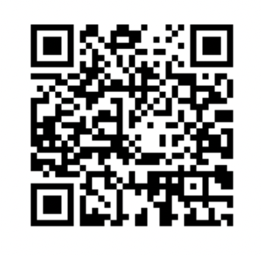
[Your Address]
Please Scan QR code to visit
People’s Vaccine Inquiry Website
www.peoplesvaccineinquiry.co.uk
[Your Address]
[Your Address]

[Date]

Dear Dr [Insert GP Name]
Re: People’s Vaccine Inquiry – Covid-19 Vaccines
As your patient, I would like to bring your attention to the recent launch of the People’s Vaccine Inquiry into the potential harms and ethical violations of the Covid-19 vaccine rollout.
You are no doubt aware that the UK Covid-19 Inquiry, established and funded by the UK Government to examine the UK’s response to and impact of the Covid-19 pandemic, recently postponed Module 4 on vaccines until 2025. In addition, on 22 May 2024, it was announced that the Inquiry will not consider all of the safety and efficacy of the Covid vaccines.
The People’s Vaccine Inquiry is comprised of expert groups who were invited to submit Witness Statements to the Covid-19 Public Inquiry Module 4 (Vaccines), and others with relevant expertise. The medical professionals who took part in the People's Vaccine Inquiry believe it is in the public interest to urgently facilitate access to expert opinion and relevant clinical observations – for both the medical profession and the public – to allow informed consent and protect patient safety.
They argue that, during the Covid era, there has been a failure of public health to ensure the public had a full picture of the potential known and unknown risks of the Covid vaccines to enable informed consent, and that the insufficiently tested Covid vaccines were rolled out in a way that violated fundamental principles of medical ethics.
I strongly encourage you to visit the People’s Vaccine Inquiry website where you can read detailed and fully referenced statements from experts from the medical and scientific fields and listen to their short video summary presentations of evidence and data that has been heavily censored in the mainstream media but which is in the public domain.
Please also share this important public health resource with your medical and nursing colleagues and patients who are still considering further Covid vaccinations.

Yours sincerely

[Your name]

